Tactical Playbook
Contents
How To Use The Playbook 4
Starting Line Plays 5
S 1 – Port Tackers On The Starting Line 5
S 1.1 6
S 2 – Double Tack Time Thresholds 7
S 2.1 8
S3 – Bail Out 9
S3.1 10
S3.2 11
S4 – Double Tack Distance Thresholds 12
S4.1 13
Upwind Plays 14
UW 1 – Lead Back With Loose Lee-Bow 14
UW 1.1 15
UW 2 – Let A Blocker Lead You To The Favored Side 16
UW 2.1 17
UW 3 – Lead Back Leading Packs 18
UW 3.1 19
UW 4 20
UW 4.1 21
Windward Mark Plays 22
WM 1 – Duck and Pin Boats On Starboard Layline 22
WM 1.1 23
WM 2 – Hurt Opponents On Layline 24
WM 2.1 25
WM 3 26
WM 3.1 27
WM 4 28
WM 5 – Pin Opponents Past Layline 29
WM 5.1 30
Down Wind Plays 31
DW 1 – Stay Between Opponent and Leeward Mark 31
DW 1.1 32
DW 2 – Sail Low After Getting Gybed On 33
DW 2.1 34
DW3 – Sail Low In A Pack Before Getting Gybed On 35
DW 3.1 36
DW 3.2 37
DW 4 38
DW 4.1 39
DW 5 – Jump The Boat Ahead Unless Separation Is Large 40
Leeward Mark Plays 42
LM 1 42
LM 2 43
LM 3 44
Finishing Line Plays 45
F 1 45

How To Use The Playbook
The following playbook is intended to be a record of lessons surrounding set scenarios on the racecourse. By documenting tactical situations, and evaluating the variables that dictate decision-making, tactics can be separated from strategy. The purpose of this playbook is to allow sailors to execute strategies while dealing with other boats using the highest percentage decisions possible.
The book is divided into sections based on where on the course the interaction takes place, which are denoted as follows:
Starting Line Plays (S)
Upwind Plays (UW)
Windward Mark Plays (WM)
Down Wind Plays (DW)
Leeward Mark Plays (LM)
Finishing Line Plays (F)

Each play is numbered for reference, and solutions to each situation are given a decimal suffix. For example, UW 3 would be the third upwind situation outlined in the book, and UW 3.1 would be the first solution. Please note that some plays have multiple outcomes depending on what variables are present.
In each scenario, the red boat is the boat faced with the tactical decision unless indicated otherwise.

Starting Line Plays

S 1 – Port Tackers On The Starting Line
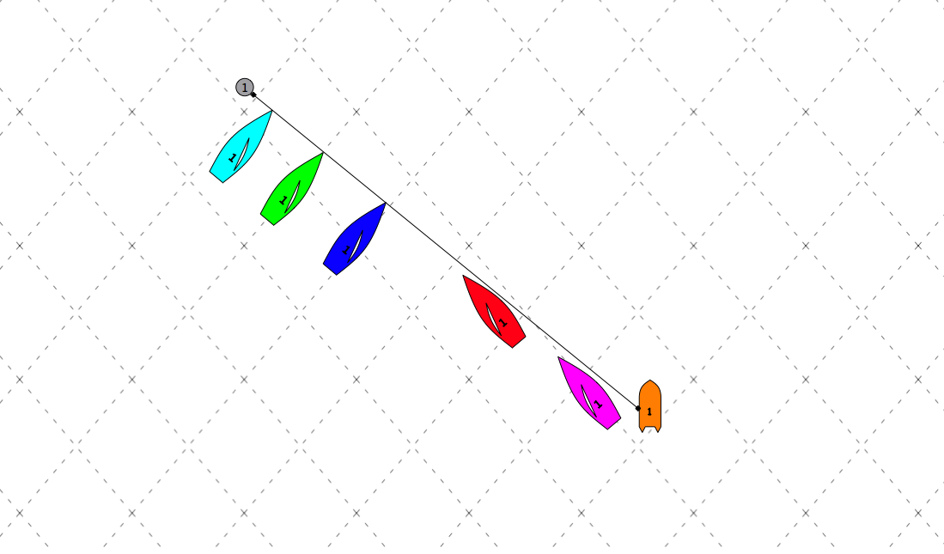
Facts
- Blue, Green, and Cyan are all crossing Red
- Red can tack and maybe cross purple
Variables
Comments:

S 1.1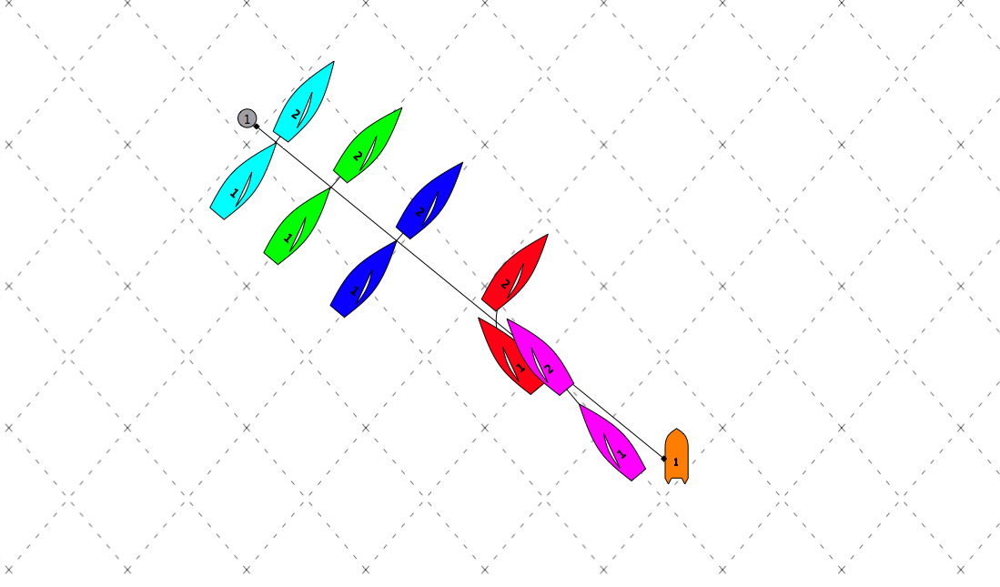
Variables
Explanation
Red should always be looking to tack if port tackers can cross, because as soon as Red takes the first stern, she must take all sterns. The priority at the start is to “escape” from the line, let the fleet thin out, and then try to make smart moves.

S 2 – Double Tack Time Thresholds
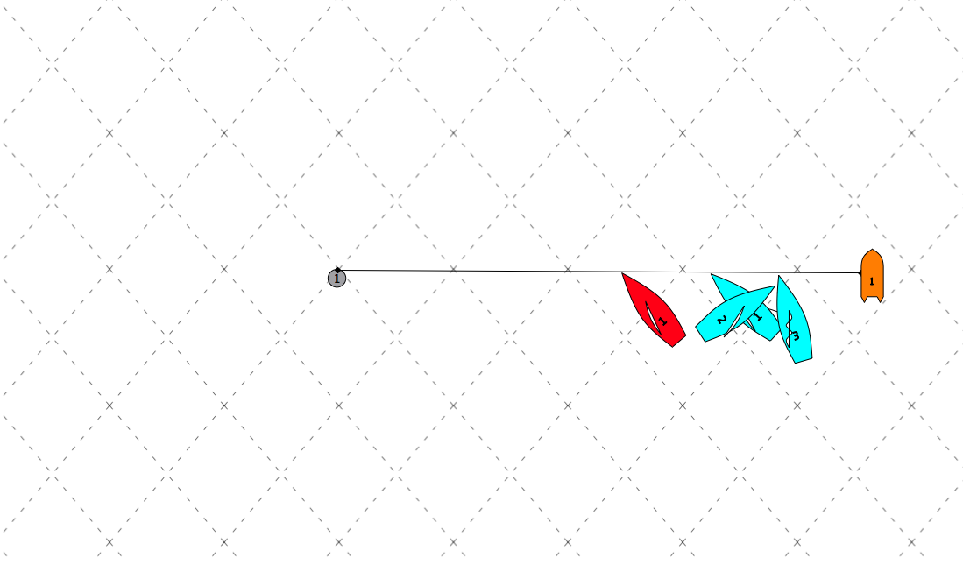
Facts
- Cyan double tacks on the start line with Red to leeward
Variables
- t = time until start
Comments:
Threshold times (t) below should be verified.

S 2.1 (49er/29er/Laser/CFJ/Opti) 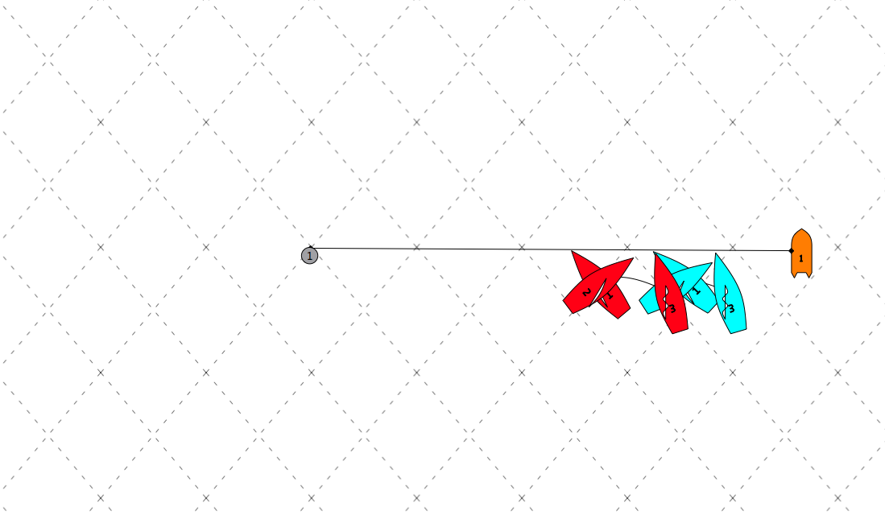
Variables
- t >= (20/20/20/15/15) seconds
Explanation
When boat to windward double tacks, Red should always double tack as long as there are (20/20/20/15/15) or more seconds until the start.

S3 – Bail Out
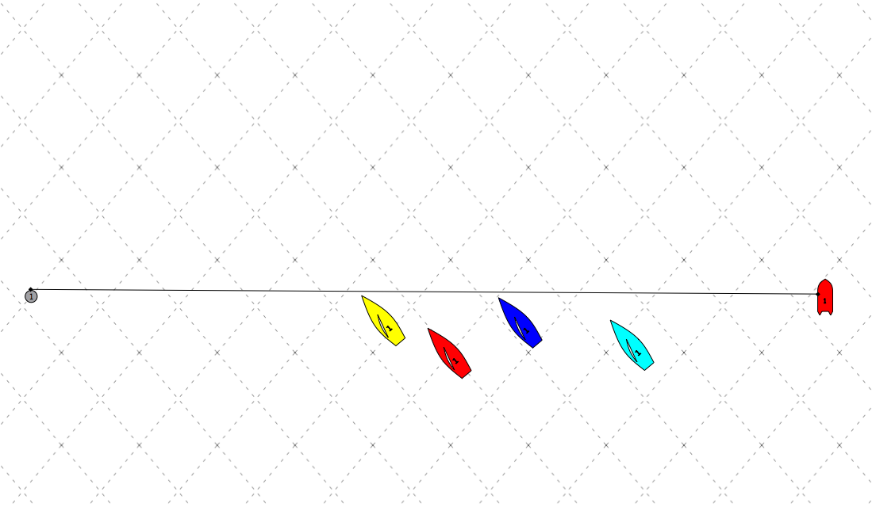
Facts
- Red gets a second row start
Variables
- Boats to the right of Cyan
- Boats to the left of Yellow (If boat accelerates when it goes bow down)
- Left, right, or neither is favored
Comments:
Can Red use Blue or Cyan as a blocker by ducking and tacking right away?

S3.1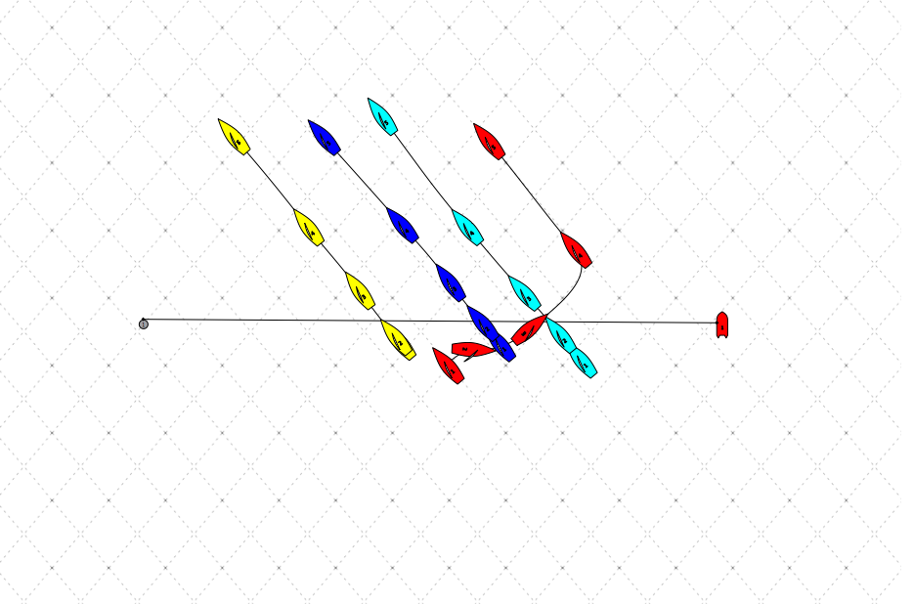
Variables
- Boats to the right of Cyan = doesn’t matter unless Red can’t hang in this spot
- Boats to the left of Yellow = doesn’t matter
- Left is favored
Explanation
Red should tack above Cyan, as close as possible without getting pinched off. In this case it is more important to get onto starboard quickly and eliminate the possibility for a boat like Yellow to lee-bow by using Cyan as a blocker, than to get totally clear as he can in S 3.2. The one exception is when there are no boats to leeward of Yellow and the breeze is very strong (15+), in which case Red should put the bow down and foot out to the left.
S3.2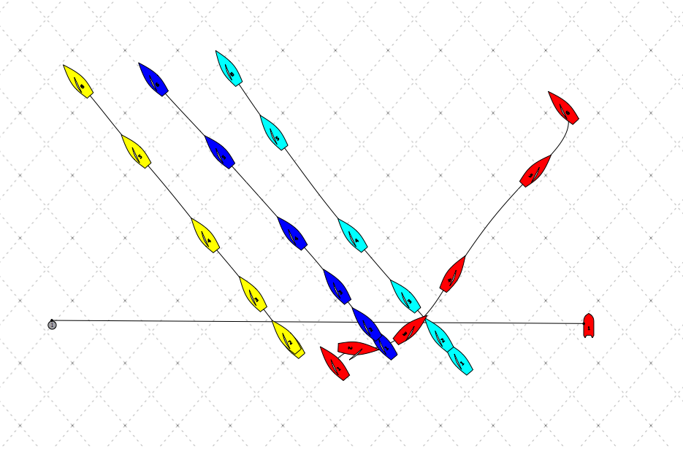
Variables
- Boats to the right of Cyan = none that red must duck significantly
- Boats to the left of Yellow = doesn’t matter
- Neither side is favored
Explanation
Red should bail out, but come back towards the fleet no more than 10 boat lengths to windward of Cyan. Unlike S3.1, there is no reason to put herself in a tight lane to fight for the left, however, banging the right is risky. The conservative move here ensures that a fast Red boat will pick off a few boats by the top, while banging the right could result in big losses. If the right ends up coming in, Red will likely be in the front of the pack anyways, and if the fleet decides to tack, it is easy for Red to lead right.

S4 – Double Tack Distance Thresholds
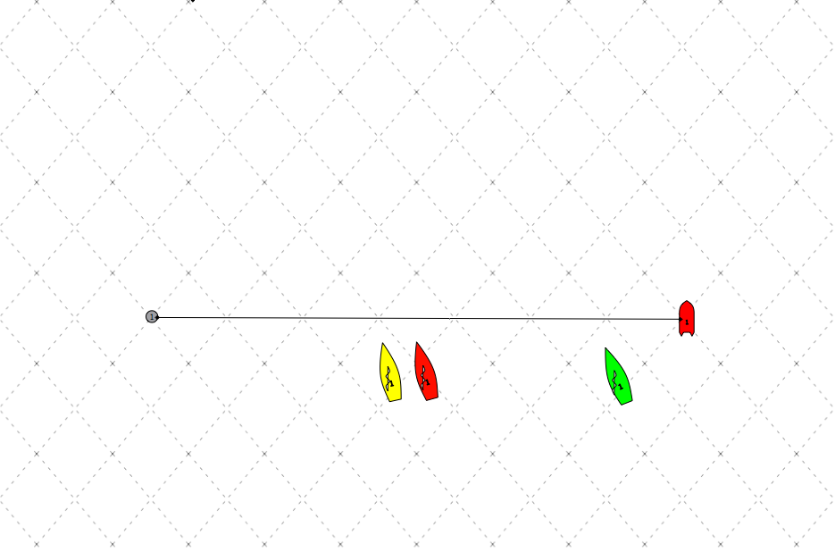
Facts
- Red is on the line before the start and has a big hole to windward and a boat tight to leeward
Variables
- d=distance to line
- x=distance to green
- t=time to start
Comments:
What are threshold d, x, and t such that you can double tack? Is it worth waiting until late in the sequence to double tack so that yellow has less opportunity to defend? Practice double tacking and accelerating right away! Threshold values below are just suggestions, and should be verified.
S4.1 (49er/29er/Laser/CFJ/Opti)
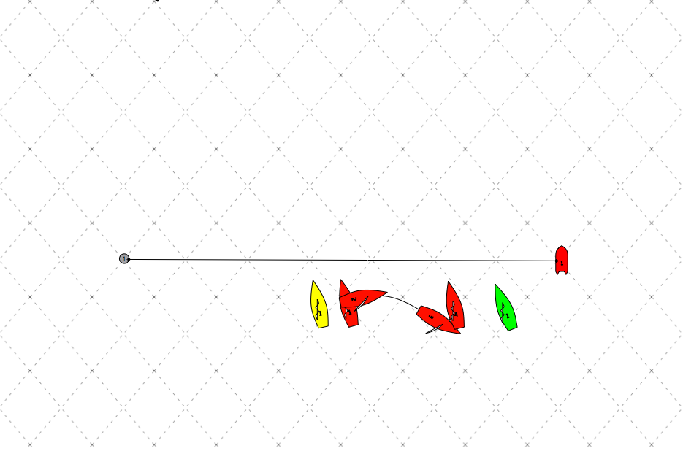
Variables
- d>= (1/1/2/2/0) boat lengths
- x>= (3/3/4/5/1) boat lengths
- t >= (25/25/20/15/20) seconds
Explanation
Wait until threshold values to double tack so that yellow cannot complete a “domino” double tack in time, or at least has to think twice.

Upwind Plays

UW 1 – Lead Back With Loose Lee-Bow
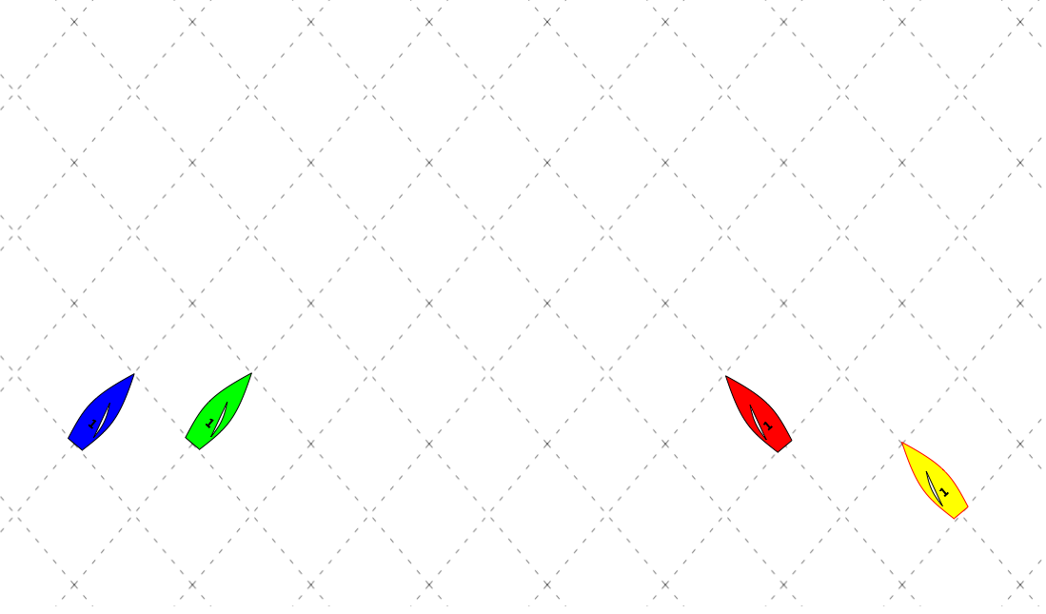
Facts
- The right side of the course is favored
- Red, Green, and Blue are nearly bow even
- If Green or Blue duck Red, they will not cross Yellow
- Red can tack and cross yellow
Variables
Comments:
What is Red’s best path to the right?

UW 1.1
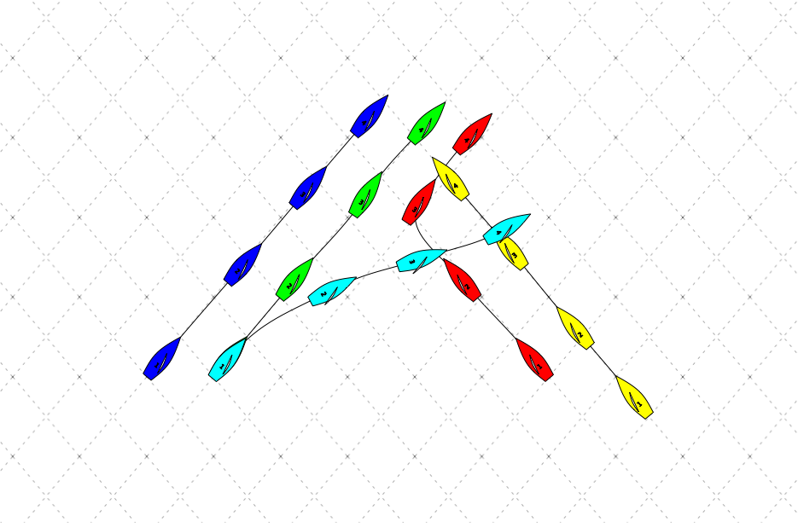
Variables
Explanation
For Red the main goal/the safest move is to loosely lee-bow Green, no matter whether Green tacks or ducks. Red’s main goal here is to eliminate Green’s ability to sail his groove by preventing her from putting the bow down for chop. As such, a tight lee-bow is not necessary, and if Green is bow even, or slightly ahead, the priority is to lead back and survive, not to put Green in bad air.

UW 2 – Let A Blocker Lead You To The Favored Side
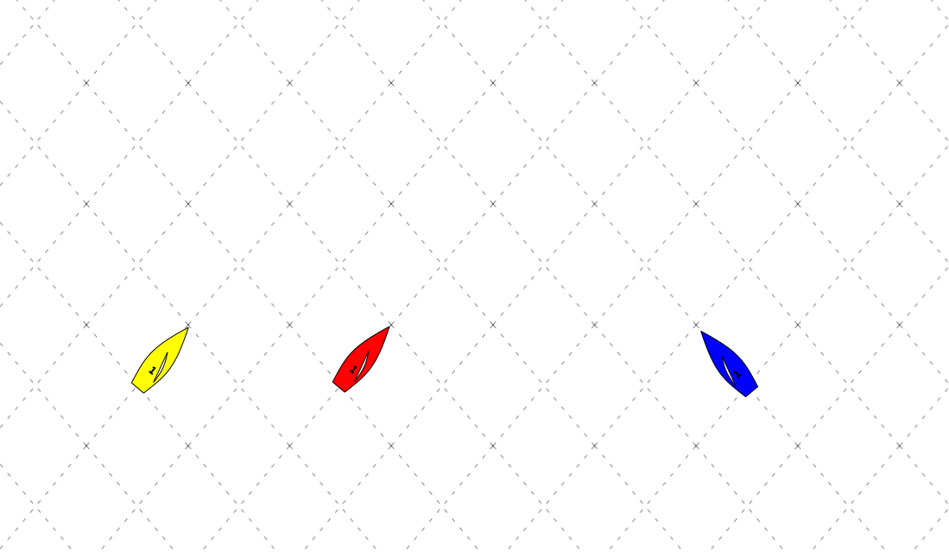
Facts
- Red, Yellow, and Blue are bow even, or red is slightly behind, but no more than 1 boat length
- The left is favored
Variables
Comments:
What is Red’s best path to the left? When do you use blue as a blocker vs. lead back?

UW 2.1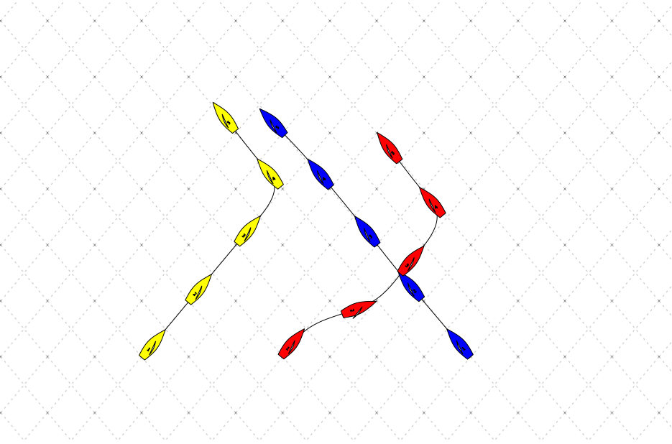
Variables
Explanation
Red should duck Blue and use Blue as a blocker to go to the left, that way there is no way for Yellow to lee-bow Red (which she would/should probably do if Red tacks before Blue). In this situation Yellow will likely lee-bow Blue and force them to tack out, or at least make it very hard for her to sail full speed.
If there is a line of boats above Blue that Red would have to deal with if she ducked Blue, Red should go early and make Yellow make a decision to tack or duck. If Yellow lee-bows, then Red might have a chance to double tack.

UW 3 – Lead Back Leading Packs
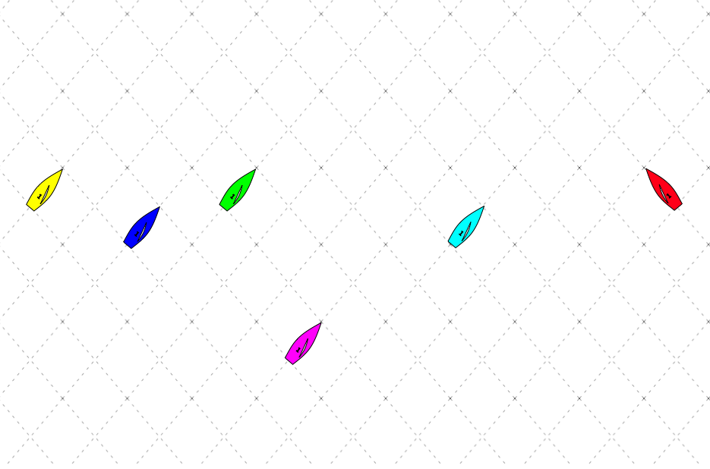
Facts
- Red is approaching the lead pack from the left and is nearly even with Green and Yellow
Variables
Comments:
Are there any variable that matter?

UW 3.1
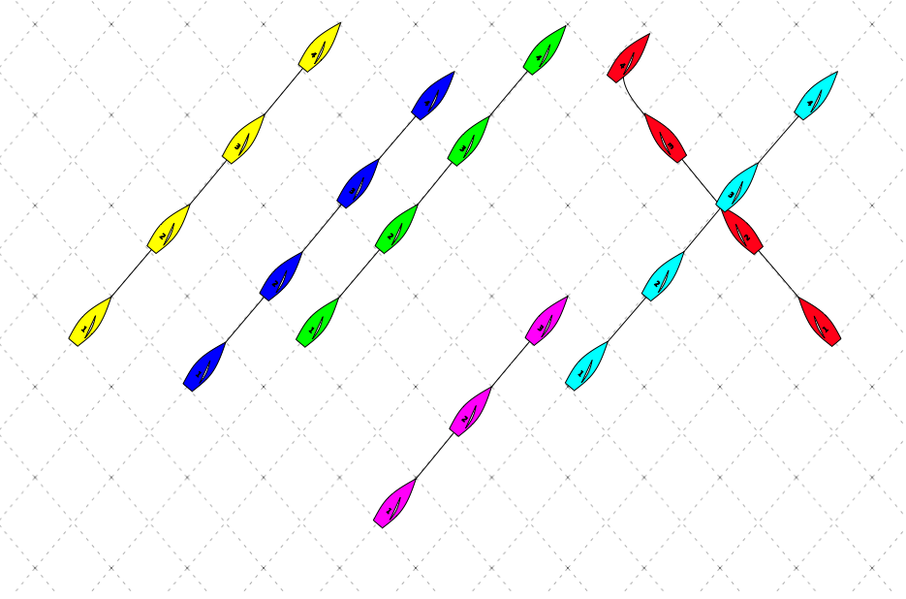
Variables
Explanation
In this case, favored side does not matter because this is the lead pack from the left, and they are all on port. Red should get as close to the leaders as possible, in order to shut down lanes, and make it difficult for Green to sail his own groove. Red should lead back regardless of which side is favored because the initial losses of ducking can probably be avoided. If left pressure begins to come in hard, it is likely that green will tack to minimize Yellow’s leverage, in which case Red will be able to go as well. This also preserves starboard advantage.

UW 4
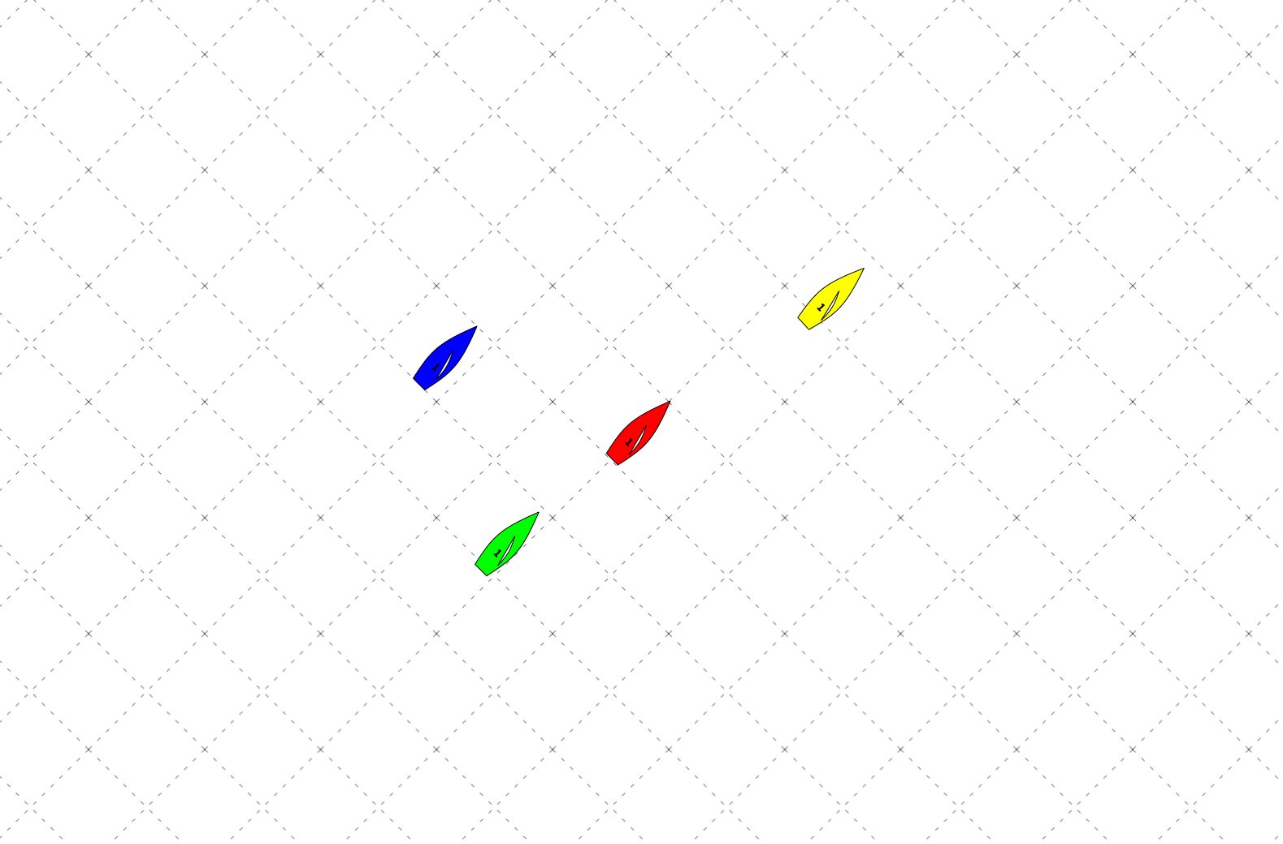
Facts
- Yellow is in a header
- Red, Green, and Blue are not yet to the Header
- Blue is footing to get into the header
Variables
Comments:
Why would UW4.1 work?

UW 4.1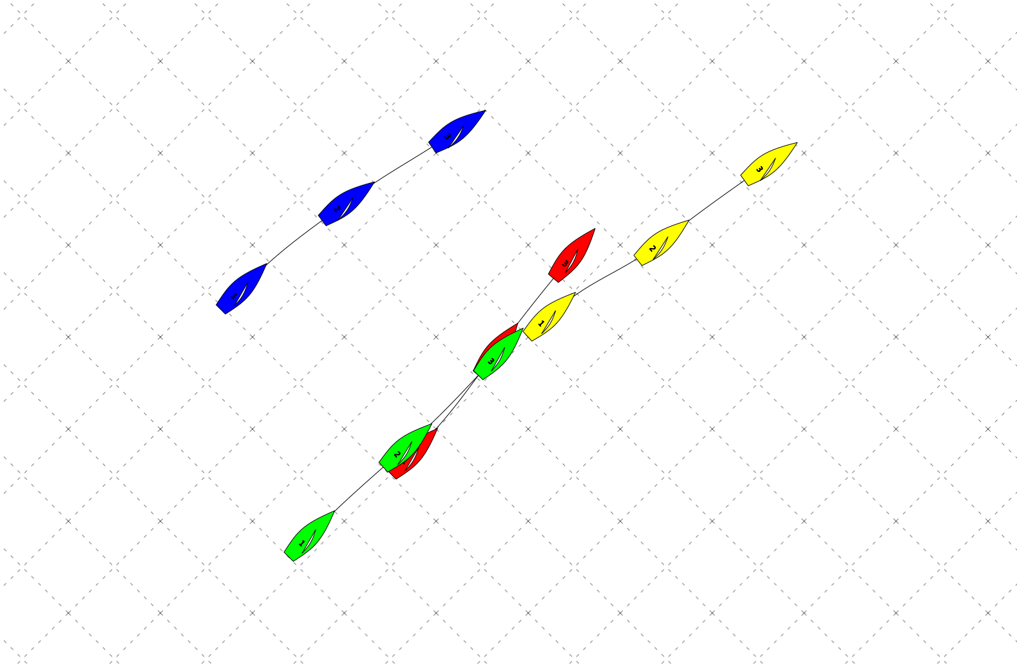
Variables
Explanation
If you are red then you pinch to stay out of the header. Blue is in the header by now so you are gaining on both of them. This scenario happened the last race of day three at Orange Bowl we pinched and gained on both of them. (DQ)

Windward Mark Plays

WM 1 – Duck and Pin Boats On Starboard Layline
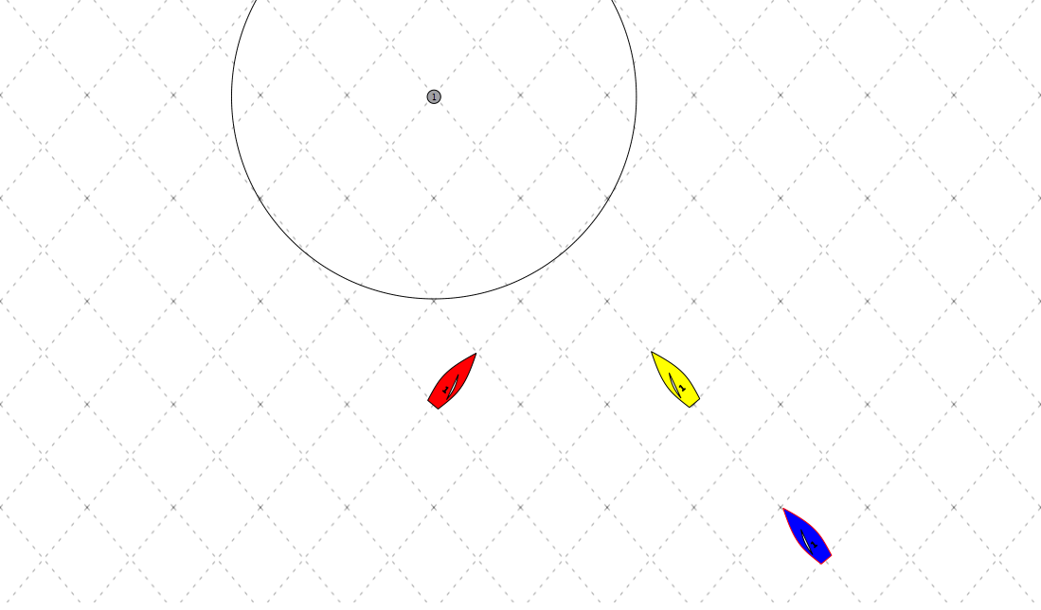
Facts
- Red and Yellow are bow even
- Yellow is on a tight layline
- Blue is a non-issue
Variables
- t = time to windward mark
Comments:

WM 1.1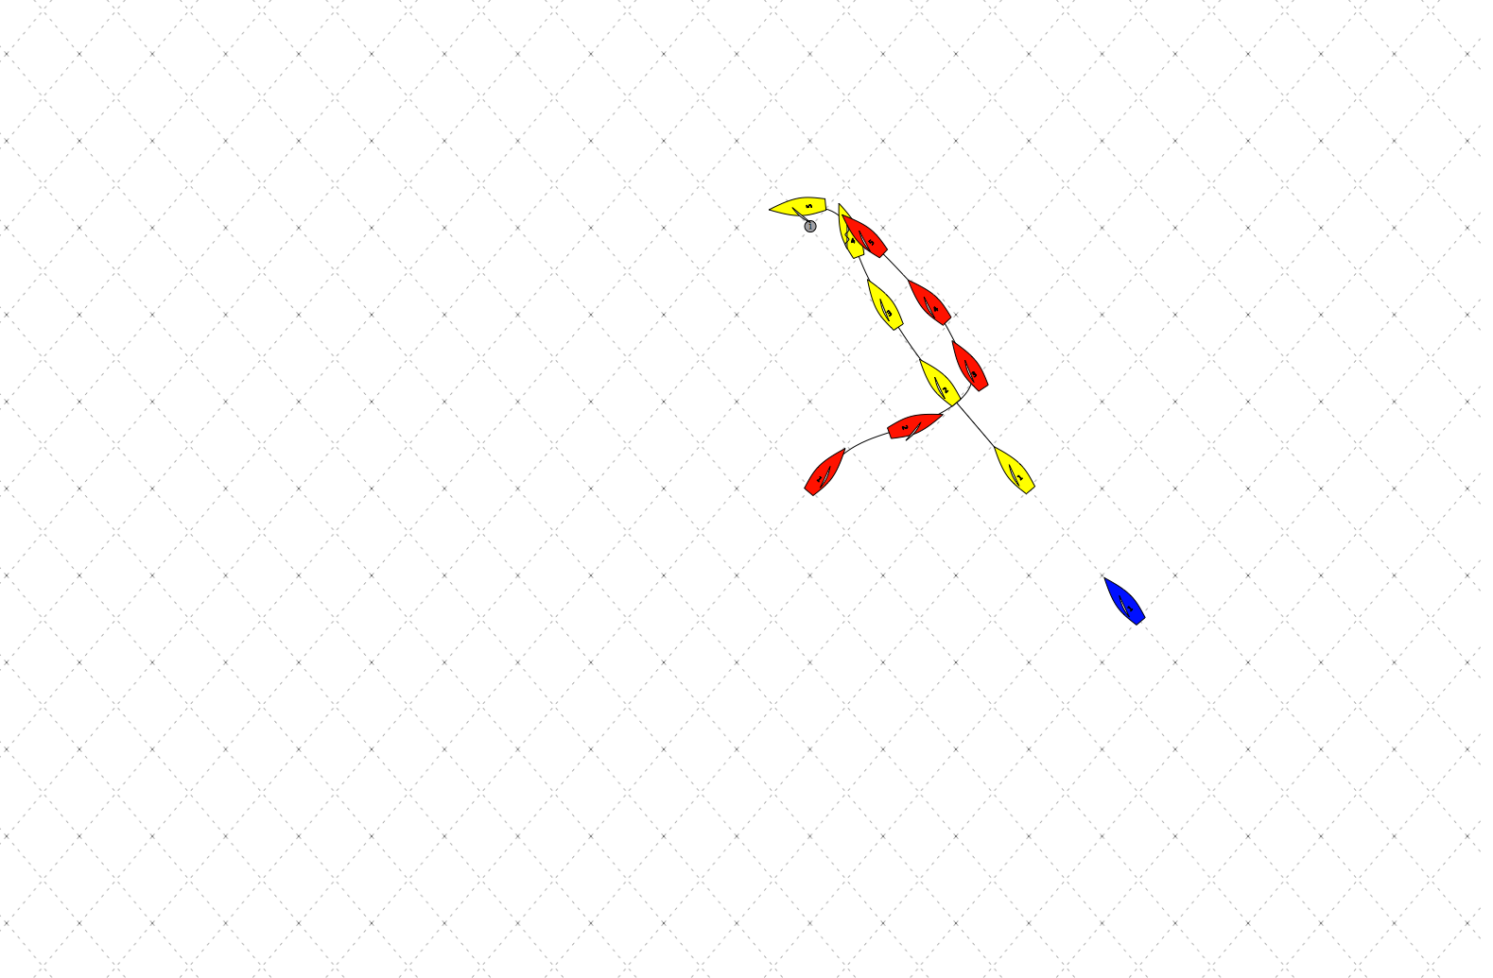
Variables
- t = time to windward mark
Explanation
If Yellow is on a tight layline and Blue is a non-issue than Red should always duck and make a safe rounding and still be in-touch with Yellow so Red can make a move on the downwind.
If t > 10 boat lengths it is possible for Red to lee-bow and force Yellow to tack out and giving Red options to (if possible) make the mark or to do a double tack and not worry about Yellow
Side Note: If Yellow is unsure whether or not they will lay, their tactic should be to tack and pin Red when Red ducks.

WM 2 – Hurt Opponents On Layline
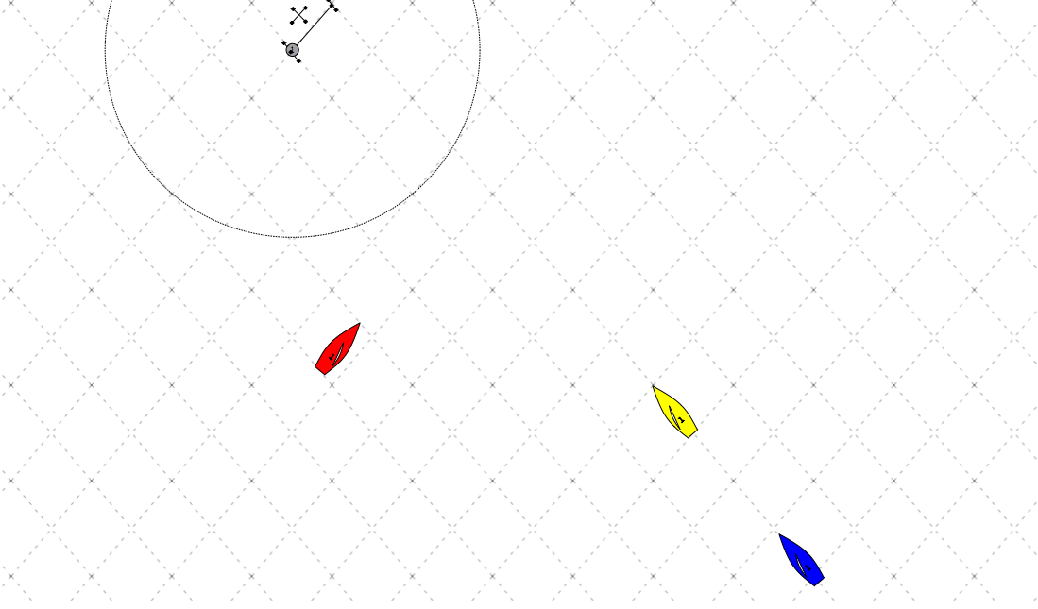
Facts
- Red is crossing yellow by a quarter boat length
- Blue is a non-issue
Variables
- t = time to windward mark
- x = distance past layline
- How badly do you need to hurt Yellow?
Comments:

WM 2.1
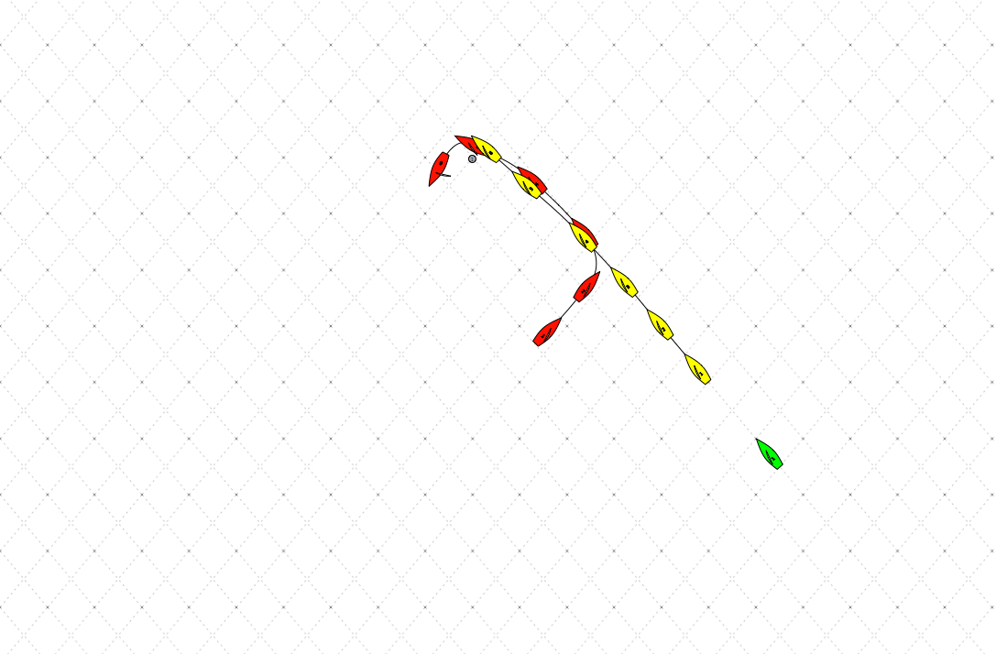
Variables
- t = time to windward mark
- x = distance past layline
- How badly do you need to hurt Yellow?
Explanation
Red should not tack on layline and instead go right in front of Yellow to make Yellow slow down. In the best case scenario Yellow might not make the mark and either way, Red creates a bigger gap.
- t = is not relevant. The farther away the better it will work.
- x = is not relevant unless it is very large. The farther away the better it will work.
Slam Yellow harder if you need to hurt Yellow. Farther away from the mark will work better because it will force them to tack or not make the mark.
WM 3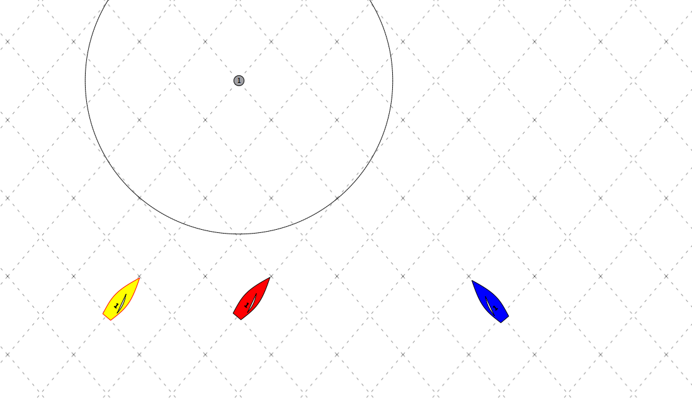
Facts
- Red, Yellow, and Blue are bow even
- Blue has called a somewhat conservative layline
- Blue is a non-issue
Variables
- t = time to windward mark
- x = distance past layline
- How badly do you need to hurt Yellow?
Comments:
When should Red use Blue as a blocker?

WM 3.1
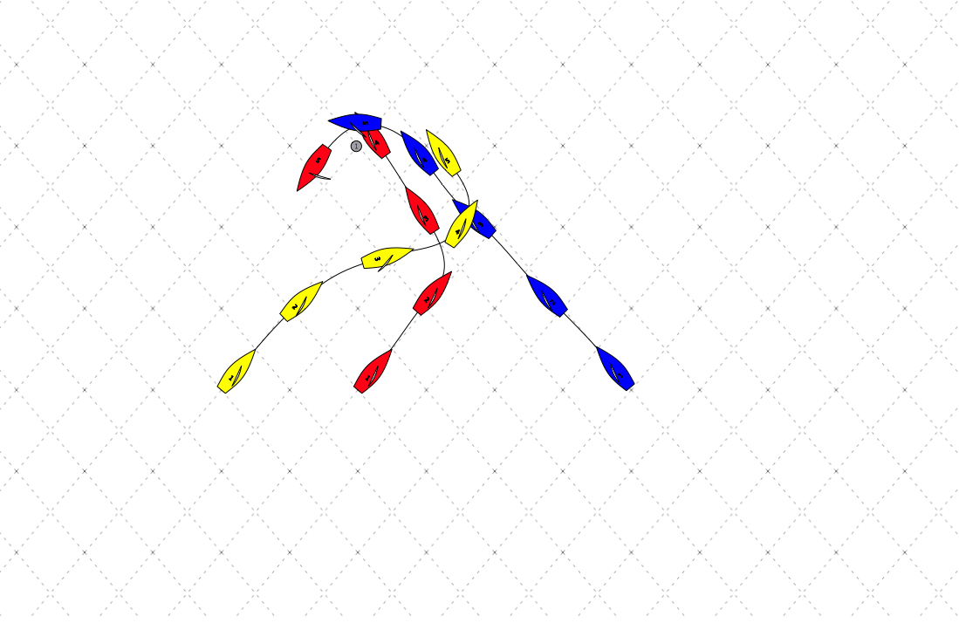
Variables
- t = about 3-4 boatlengths
- x = The closer Red is to the port layline the better it will work because it will give less of a possibility of making the mark if Yellow decides to tack.
- How badly do you need to hurt Yellow?
Explanation
Red tacks on layline so that Yellow is forced to duck Red and Blue.

WM 4
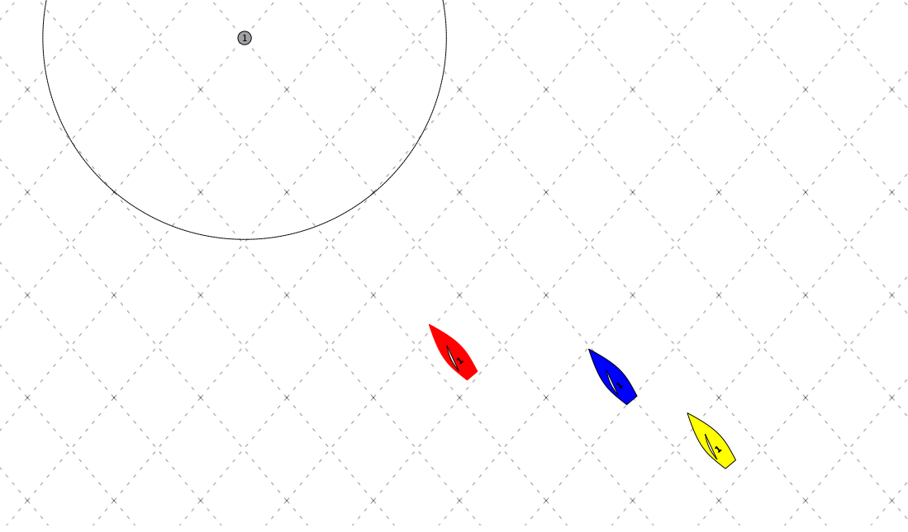
Facts
- Red cannot tack and cross blue
- Red is not on layline
- Blue is laying
- If red ducks Blue, there is likely a line of a few boats (Yellow) who red will have to duck
Variables
- t = time to windward mark
- x1 = Red’s distance under layline
- x2 = Blue’s distance over layline
- How many boats are in the line with Yellow?
Comments:
Do any of the variables listed change the eventual move?
WM 5 – Pin Opponents Past Layline
Facts
- Blue cannot tack and cross Red
Variables
Comments:
What is the defense if you are Blue?

WM 5.1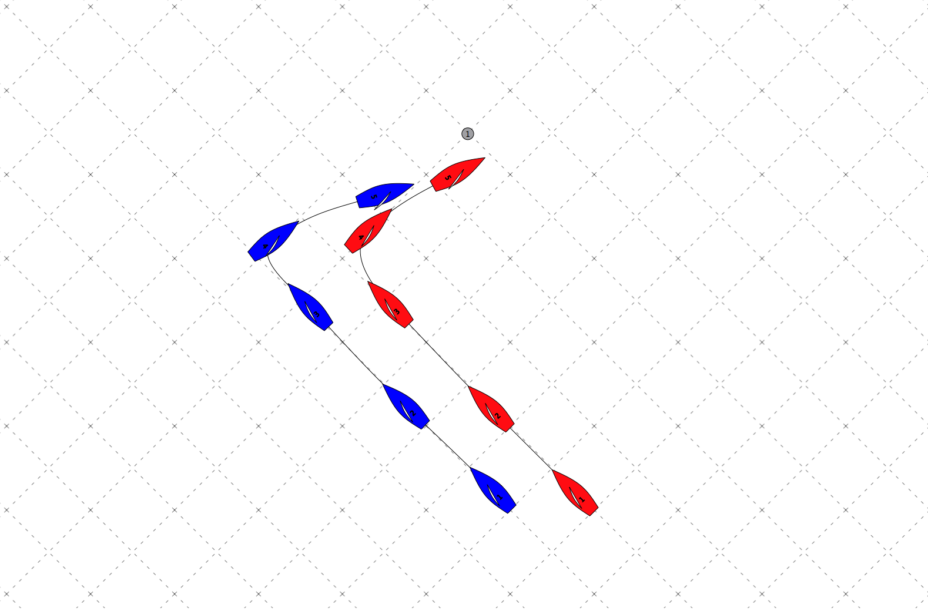
Variables
Explanation
Red most go all the way to (or past) layline to pin Blue out. The defense for Blue is to tack early and duck, in which case Red should again tack to pin. Preserving Starboard advantage is very important.

Down Wind Plays

DW 1 – Stay Between Opponent and Leeward Mark
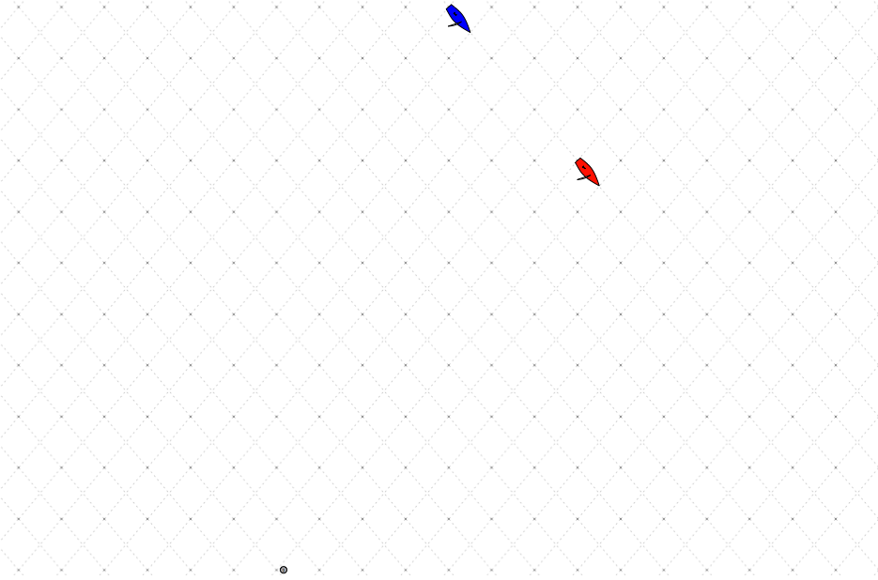
Facts
- Red has a lead on blue
- Red is not on layline
- Blue has leverage in the direction of the mark
Variables
Comments:

DW 1.1
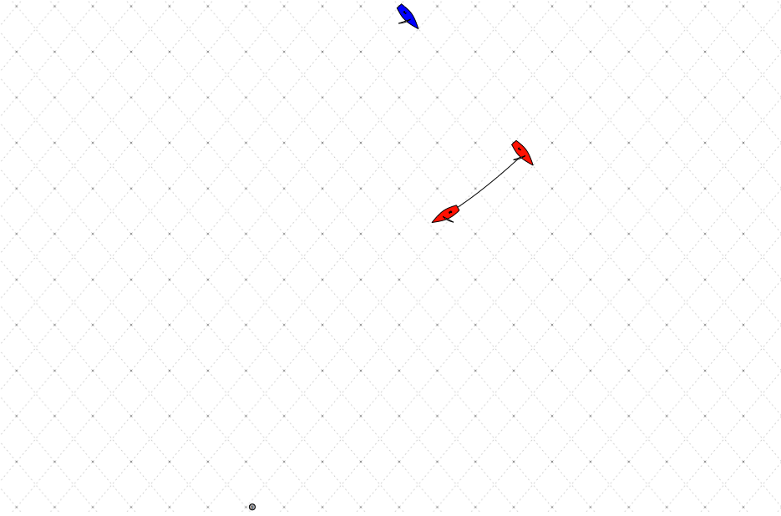
Variables
Explanation
Red should lead back towards the mark before Blue is tempted to gybe back with them so that she can get in between Blue and the mark. At position 2, where Red has gotten to the mark side of Blue, if Blue has extended towards the right (looking upwind), then red should gybe back to keep leverage minimized, but there is a good chance that Blue will gybe with Red.

DW 2 – Sail Low After Getting Gybed On
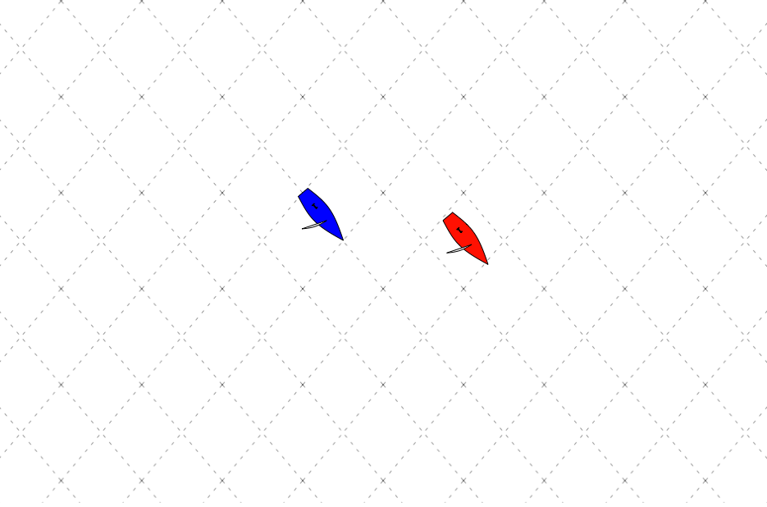
Facts
- Red has a lead on Blue and can gybe and cross
- If Red gybes, Blue can gybe on Red
- Left looking upwind is favored
Variables
Comments:

DW 2.1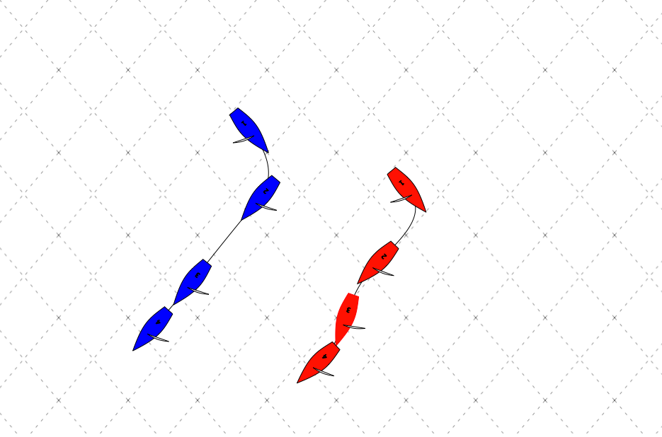 Variables
Explanation
Red should gybe at blue forcing them to make a decision. If Blue extends, Red is free to sail to the favored side, but must be sure to stay in touch with the fleet (80/20 rule, or no more than 10 boat lengths beyond Blue, if blue is the leeward most boat). If Blue is in phase and paying attention, she should gybe to cover, in which case, Red might need to do a quick wiggle to leeward to keep her bow clear behind Blue’s wind shadow.

DW3 – Sail Low In A Pack Before Getting Gybed On
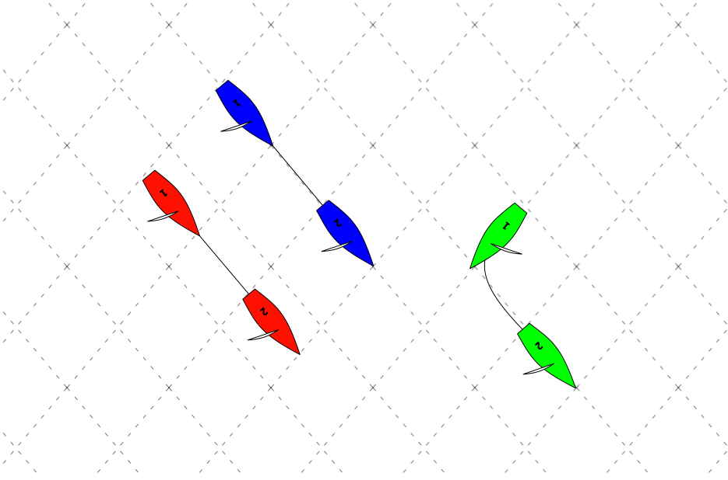
Facts
- Red has clear air, but just barely
- Green gybes on Red and Blue
- Red can’t get up over green without being in blue’s bad air
- Right looking upwind is favored
Variables
- Boats behind Blue and Red who will be on Red’s air if she gets immediately to the left of Blue
Comments:

DW 3.1
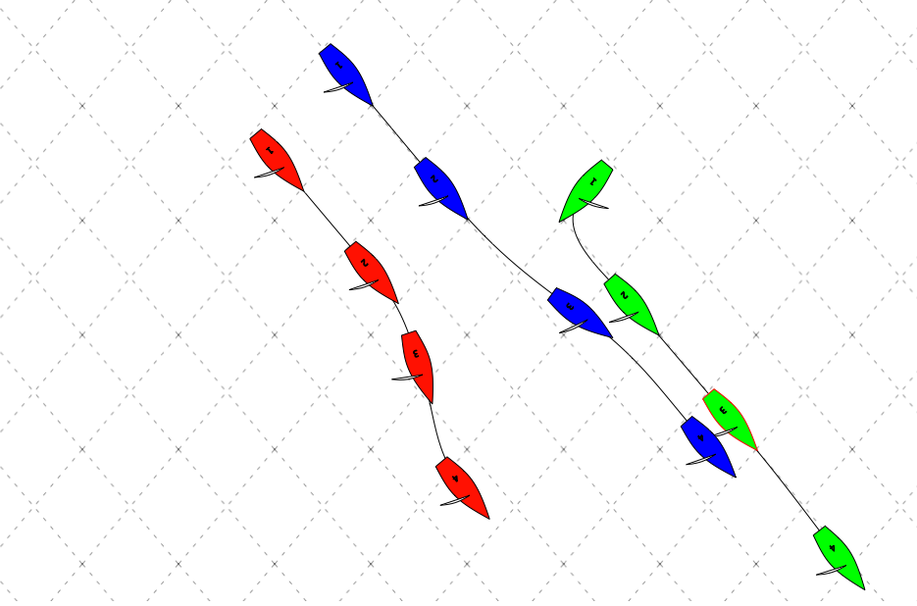
Variables
- No boats immediately to the left of red and blue
Explanation
With clear air behind and to leeward of Blue, Red should soak hard, as soon as she realizes that Green will gybe in. By carrying momentum low, and then sailing in a soak mode as necessary, she should be able to get clear air low, and maintain position on (almost) the same ladder rung. The key here is to execute early if you see it coming.

DW 3.2
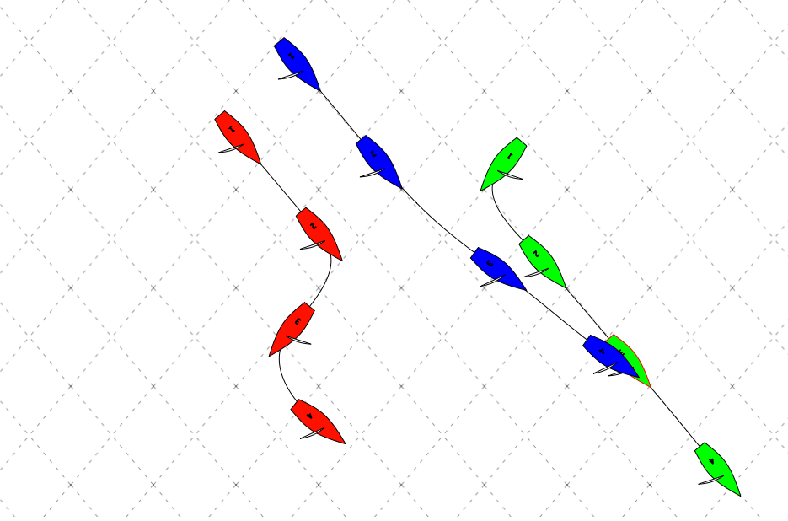
Variables
- There are boats immediately to the left of red and blue
Explanation
Unlike DW 3.1, in this case soaking is not enough to get clear, so red should gybe immediately when green gybes in, and then gybe back to clear out. The key here is to execute early if you see it coming.

DW 4
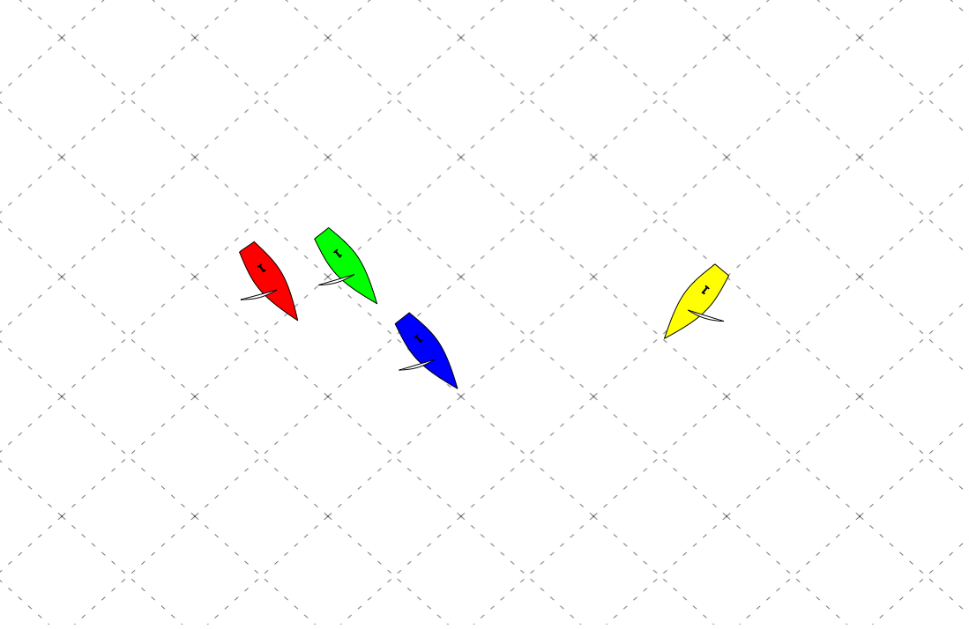
Facts
- You are Yellow
- You are nearly even with Blue
- No favored side
Variables
Comments:

DW 4.1
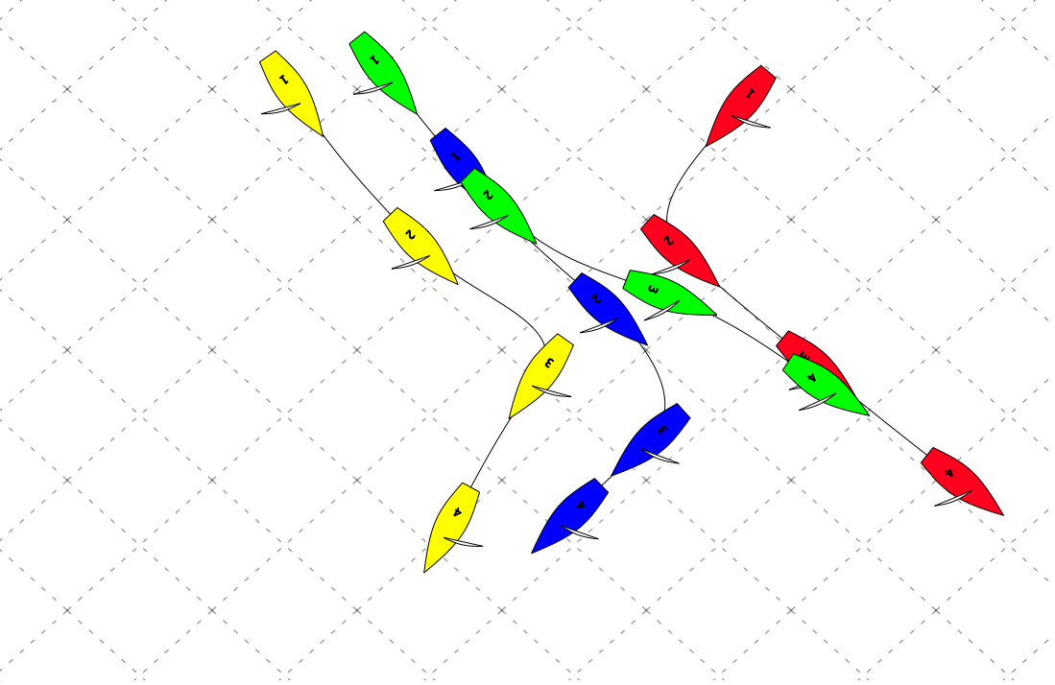
Note: Red and Yellow colors switched from 4 to 4.1
Variables
Explanation
Red should gybe on Blue, expecting that Yellow is looking for an excuse to gybe out, and will probably also hit Blue. Red now controls the Left pack (looking downwind), and establishes a situation similar to DW 2.

DW 5 – Jump The Boat Ahead Unless Separation Is Large
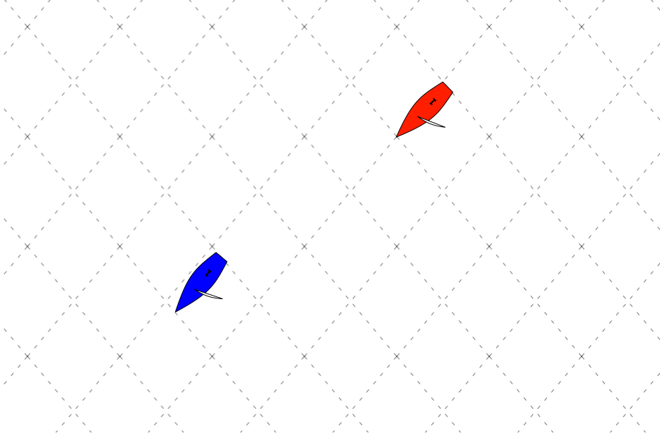
Facts
- You are Red
- You are not yet to lay line for the leeward mark or the finish line
- There is no pressure from boats behind
Variables
- D = Distance between Red and Blue
- L = Lateral distance (gage) between Red and Blue
- F = Favored side
- X = Distance to finish
Comments:
DW 5.1
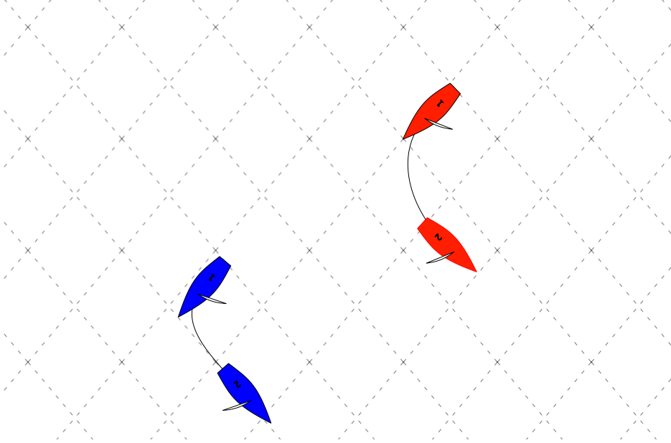
Variables
- D < 8 boat lengths
- D/X < 1 boat length/50m
- L>0
Explanation
In scenario DW 5, Red is setting up to jump Blue on the next gybe. This is the high percentage move, as Red maintains contact with Blue, and remains in control of her destiny, but the farther ahead Blue is, and the closer to the finish the pair get, the more difficult it gets for Red to affect Blue’s air, so the longer it will take to make the pass. At a certain ratio of distance from the line to separation, Red should gybe away, and look for opportunities on the other side of the course to come back with starboard advantage. If Blue rounds the top mark with a lead >8 boat lengths, the leverage should be created immediately by gybe setting, but if Red is in touch, she should pursue Blue as long as the lead does not grow to more than 8 boat lengths, or the distance to separation ratio doesn’t shrink below 1 boat length per 50m to the finish line.

Leeward Mark Plays

LM 1
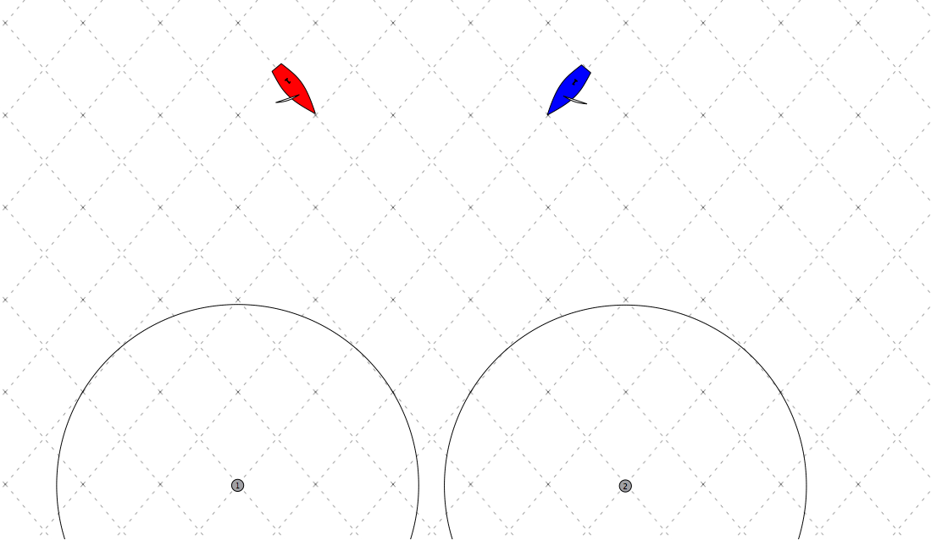
Facts
- Red and Blue are bow even and each is laying the opposite gate
Variables
- t = time to leeward mark
- F = Favored gate
Comments:
If Red likes the left, how does he go left? If he likes the right, how does he go right?

LM 2
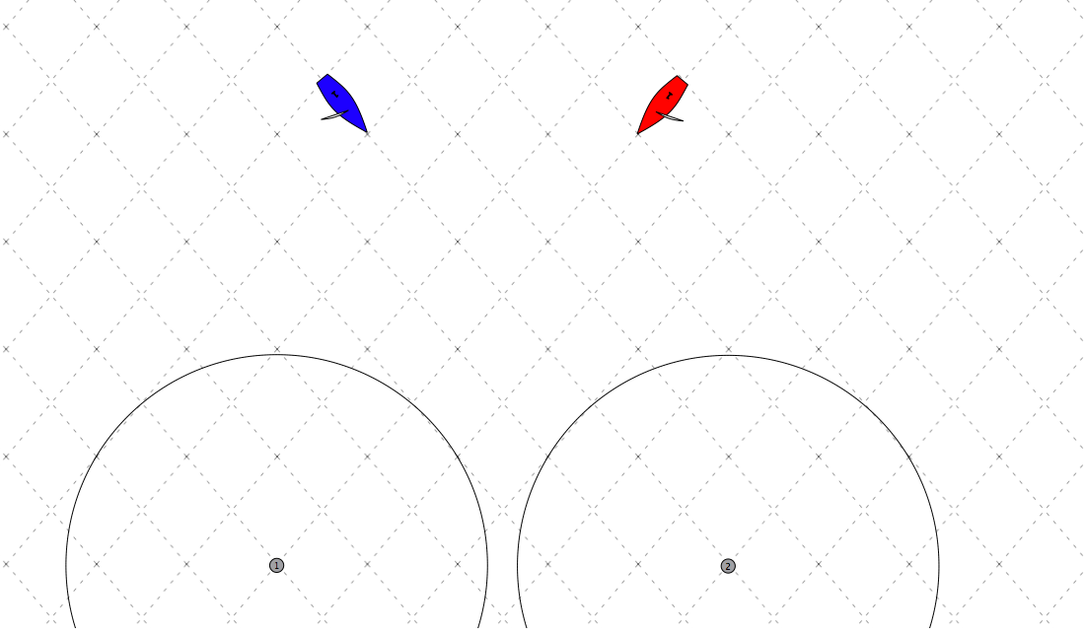
Facts
Red and Blue are bow even and each is laying the opposite gate
Variables
t = time to leeward mark
F = Favored gate
Comments:
If Red likes the left, how does he go left? If he likes the right, how does he go right?

LM 3
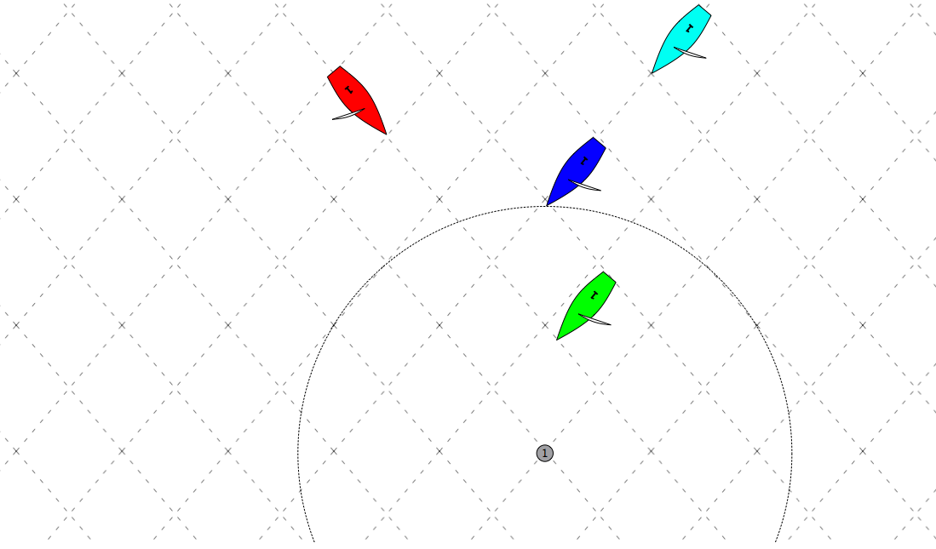
Facts
- There is one boat length between Blue and Cyan
- The mark is to be rounded to port (counterclockwise)
Variables
- t = time to leeward mark
Comments:
Does Red try to get overlap, or try to preserve “clear ahead”?

Finishing Line Plays

F 1

